EPOS TEE SHEET – GUIDE TO WHAT’S CHANGED
Login 2
Getting Access
Forgot your Password
Adding an employee
Changing a user’s password
Tee Sheet Tools 4
Green Fee Rates Tool
Users 5
Contacts 5
Tee Sheet – the differences 5
Weather & Rounds Summary
Customer Blade
Booking Notes
Pay, Multi-Pay and Group Pay Buttons
Creating a second group booking to an existing tee time
Calendar Colour
Search for a booking
Bookings – the differences 8
In Grid Editor
Tee Sheet Reports
Customers Tab 8
Creating a new customer
Searching for an existing customer
Customer information within the profile

Login
Getting Access
G1 Tee Sheet is a new system which means you have new credentials.
Firstly to access the system you need this URL
https://app.g1.brsgolf.com/App/Admin/Login.aspx
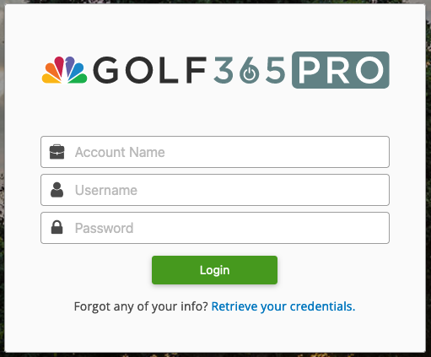
- Account Name is the name of your club. Note: this must be in lowercase e.g. longhirsthall, mygolfclub.
- You will be supplied with a Username and Password. Note: the password must be changed the first time you login.
- Passwords must be a minimum of 8 characters including a capital letter, lowercase letter, number and special character e.g. !@£$%^&*.

Forgot your Password
On the login page, click on the Retrieve your credentials link.
Enter the account name (clubname) and your username.
You will be sent an email with a link to use to reset your password. Click on the link to go to the Password Reset page and enter your new password.
Don’t forget, Passwords must be a minimum of 8 characters and MUST contain special characters e.g. !@£$%^&*
Passwords change every 30 days. You will be prompted to reset your password and given 7 days in which to make the change.

Adding an employee

Step 1: Employee information
- Navigate to System Settings then Employees.
- Click “New Employee”.
- First Name: Enter the employee’s first name.
- Last Name (Optional): Enter the employee’s last name.
- Gender: Select the employee’s gender.
- Email: Enter the employee’s email address. If you want this employee to receive email notifications from the system, this is the email address that GolfNow One will use.
- Create Login for this Employee (Recommended): Check the box to create a login that connects the employee to a G1 user account. If you check this box, you’ll add login information in Step 5. Logins can also be created separately and connected later.
- Type: Select Freelancer.
- Status: This field is useful when an employee leaves your business. For now, just leave this as Active.
- Employee Notes (Optional): Use this field to store additional information or notes about the employee for Admin use only.
- Contact Information (Optional): Enter the employee’s contact information.
- Click Continue.

Step 2: Compensation and benefits
This section can be skipped, click Continue.
Step 3: Select services
This section can be skipped, click Continue.
Step 4: Skipped

Step 5: Create login
Create a login for the employee. This will appear if “Create Login for Employee” was selected in Step 1.
- Fill in the following information:
  - First Name: Enter the user’s first name.
  - Last Name: Enter the user’s last name.
  - Email: Enter the user’s email address. Email is also used to send “forgot password” links.
  - Roles: Select user role(s) that best fit the employee’s responsibilities and how he/she will use G1.
  - Default Page: Select the starting page the user will be directed to once logged in.
  - Username: Create a username.
  - Password: Create a password. This needs to be a minimum of 8 alpha numeric characters including a capital letter, lowercase letter, number and special character e,g, e.g. !@£$%^&*.
  - Retype Password: Retype the password for security.
  - Allow Universal Login: Select Yes to allow the user to log in from any location. Select No to restrict access the user can only log in from the IP address(es) specified in System Settings > Security.
  - Require password change at next login: Check this if the user is not present to set their own password and you would like it to be changed the next time he/she accesses the system.
- Click Finish.
Step 6: Application setting
This section can be skipped, click Continue to complete the employee creation.
Changing a user’s password
- Navigate to System Settings, then Logins.
- Find the user in the list and click Edit in the Actions column.
- Scroll down to the Login section. From this section, you can change the username and password.*
- Check “User must change password next login” if you’ll allow the user to set his/her own password after they log in with the password you just entered.
- Click Submit.
*If you change the user’s password using this method, the system will not send an automated email with the new password. Be sure to give the user his/ her new password.

Tee Sheet Tools
At any time you can view the Tee Sheet Tools menu by clicking on the System Settings cog in the top right of the G1 menu. The settings that display depend on your G1 access privileges.
Navigate to Tee Sheet Settings > Tools.
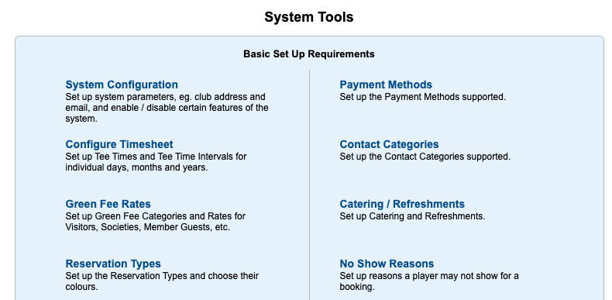
Green Fee Rates Tool
The Green Fee Rates tool has been upgraded in G1. You can now create a single green fee that has multiple availabilities.
Your original green fee rates have been converted to this format.

Multiple availabilities per Green fee
In G1, you can create multiple availabilities within one green fee rate. This will provide more flexibility to have different rates for different times of the day without the need to have separate green fee rates.
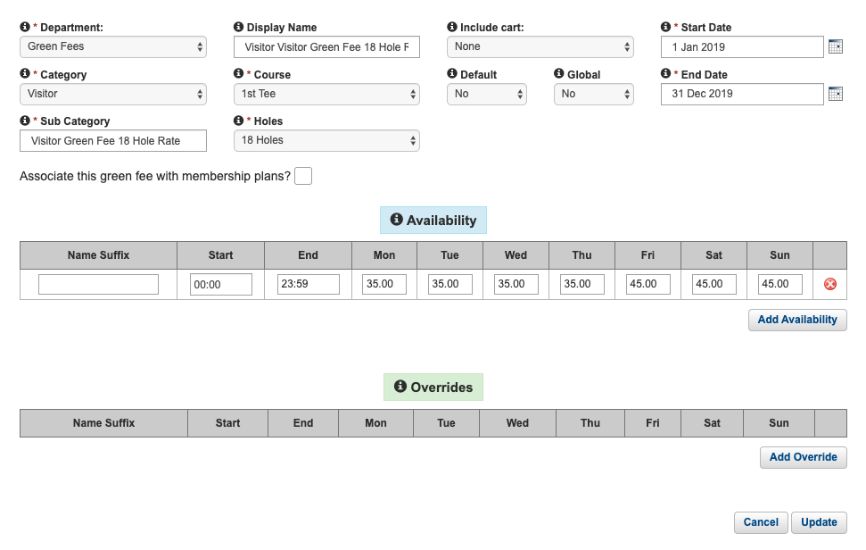
Overrides
Overrides give you the ability to change the rate of a green fee for a particular time or date without having to edit the existing green fee. An override will always supersede the rate it is overriding. This is particularly useful when you may want to change a rate for a public/bank holiday - providing you with more control over your green fee rates, while also allowing you to manage them in a quicker, easier fashion.

Default rate
You can also set a default green fee rate within the G1 system. This is the rate that will be added to players on the tee sheet, by default, if there are no other rates setup for the player based on the customer group or membership type.
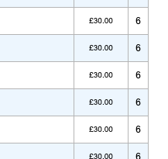
This feature has been added to streamline the process of adding players to the tee sheet. You can only have one default rate setup at any given time, otherwise, the tee sheet would not be able to auto select an appropriate green fee rate.
Default rates will display on the tee sheet.

Users
All your user/member details have been migrated to G1 and can be found in the Customers tab. Each member is customer that has a membership plan.
Members can continue to manage their contact information either through the Members App or the Member Booking Module. However, if you do need to make changes you should do so in your membership software, if you use same.
You can make changes to members in G1 by navigating to System Settings > Tee Sheet Settings > Users.
Enable/Disable Members
- Use the Retrieve Users panel to search for the member or user.
- Click on the Plus icon to enable or disable the member.

Contacts
All your contacts have been migrated to G1 and can be found in the Customers tab. At present there is some information that could not be migrated, that is Company/Group Name and Contact Category. You can continue to search for contacts using their Company/Group Name.
There are several ways to make changes to contact details:
- Customer Blade on the tee sheet, see details below.
- Booking Details page.
- Customers tab, see details below.

Tee Sheet – the differences
Weather & Rounds Summary
Weather: The weather forecast displays at the top of the tee sheet. Weather will display on today’s tee sheet and the tee sheet for the next 11 days. Weather will not display on past dates.
Round Summary: Shows the number of player slots that are available, are booked, the percentage utilisation and the projected revenue.
Note: project revenue excludes revenue in the Group Green Fees section of the booking details.
Customer Blade
Creating a Customer using the Blade
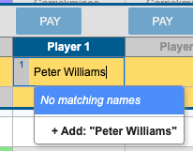
- Navigate to the Tee Sheet tab.
- Click on an empty player slot on any tee time to open the In Grid Editor.
- Type the name of the person to initiate the customer search.
- Add a new customer by clicking “+Add: “abc abc”” in the search results.
- The customer tee sheet blade appears on the right hand side of the screen.
- Complete the customer details and click “Save”. Note: Email or Phone are required fields.
- Click “Close”. You should see the “person icon” next to the player’s name.
- Note you can press “Enter” on your keyboard to quickly create “Guest with …” in each of the remaining player slots.
Editing a Customer using the Blade
- Navigate to the Tee Sheet tab.
- Click on “person icon” located next to a player’s name on the tee sheet.
- The customer tee sheet blade appears on the right hand side of the screen.
You can view / edit the following:
  - Current tags associated to the customer / add new tags to the customer
  - Membership(s) purchased
- Click “Close” to exit the blade, or “View Profile” to view the full customer profile.
Booking Notes
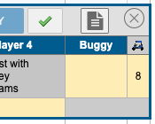
- Navigate to the Tee Sheet tab.
- Click the “Booking Notes” button located in the top far right of the In-Grid editor to enter in notes pertaining to this booking.
- Enter in the booking notes and click “Apply” to save.
- To save the reservation, click “Add” or click “Modify.”
You will see the Booking Note icon on the tee sheet, which acts as a visual that there are notes pertaining to that booking. Additionally, the staff will be able to hover or click on the Booking Notes icon to access the notes.
Pay, Multi-Pay and Group Pay Buttons
These buttons are currently disabled.
Creating a second group booking to an existing tee time
Utilize this functionality when you are looking to book a second/separate group booking within the same tee time. You can accomplish this by using the In-Grid Editor or the Booking Details Screen.
Using the In-Grid Editor:
- After making your first reservation, you will see a tab with “+” next to the “Booking 1” tab. .
Alternatively, click on an empty player slot on the tee time and a new booking will be started automatically. 
- A “New Booking” tab will appear where you can now reserve your new group. To save the reservation, click “Add.”
- Once saved, you will see a line in the far right row, informing you that there is are separate bookings on this tee time.
Reservations will also be highlighted by the group number to the left of the name (1 or 2).
You can have up to 4 individual bookings per tee time.
- Click on Booking Details to see the each booking separated.
Using the Booking Details method:
- Navigate to the Booking Details page.
- After you fill in the first booking information, click the “Create a 2nd Booking on this Tee Time” button.
- Select “Players” to add to your group, which will prompt you to fill in a name and Green Fee category.
- To save the reservation, select “Update.”
- Selecting “Update” will save your information and take you back to the tee sheet. “Apply” will save your work and keep you on the Booking Details page.
Calendar Colour
If the calendar bar at the top of the tee sheet page displays with a red background, it means you are not viewing today’s tee sheet.


Search for a booking
The Search feature is now called Find Tee Time and is at the top of the teesheet page.
Here you can search for any tee time using the Reservation Name, Player names, Customer name, booking reference number, Email address, Telephone number, Mobile number or Postcode.

Bookings – the differences

In Grid Editor
- On an empty tee time, adding a player to player slot 1 will backfill the Reservation Name AND will populate the customer details in the booking details screen.
- Use the “Enter” button on your keyboard to quickly assign “Guest with…” to subsequent player slots.
- Create a new customer using the Customer Blade, see above.
- A green fee rate is assigned automatically to the player slot if
  - The player is a member and member green fee rates are being assigned automatically, or
  - A default green fee rate has been created.
- Booking notes can be added by clicking on the “Notes” button
- A new booking is started when you click on an empty player slot.

Tee Sheet Reports
To view the Tee Sheet Reports, navigate to System Settings > Tee Sheet Settings > Tee Sheet Reports
The familiar Reports menu will display.

Customers Tab
Creating a new customer
- Navigate to the Customers tab.
- Click the New Customer button.
- Fill in the required fields:
  - First Name
  - Last Name
  - Email or Phone number
- Fill in additional information about the customer.
- Click Save.
Searching for an existing customer
- Navigate to the Customers tab.
- Use the “Find a Customer” search box to find an existing customer.
Please note, when searching via name, you will be able to search by first or last name.
Customer information within the profile
You will find the following information about a customer within their profile:
Summary Tab
- Membership Type
Details Tab
- Edit the customer’s contact information
Tags Tab
- Shows you the tags associated to this customer
- You have the ability to add/remove tags as needed customer through this tab as well

